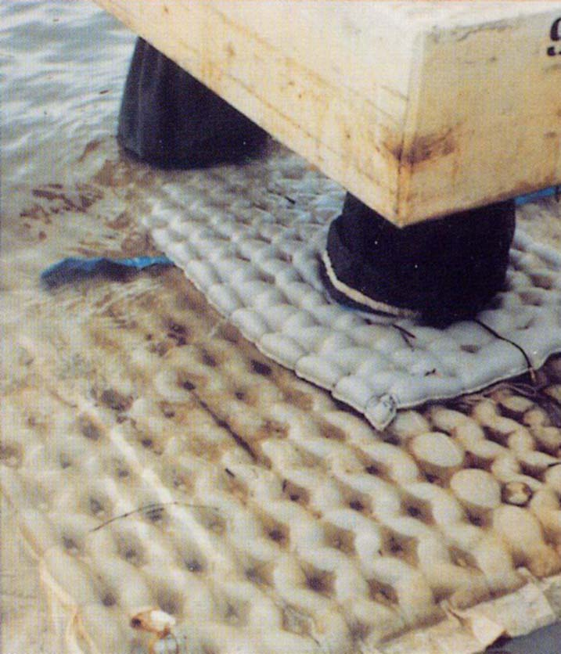

**Engineer: Halcrow Mattress Engineering**: Proserve **Contractor**: Dharsamin

CASE STUDY: bow thruster, propeller | indonesia | 1983

The port was expanded in the early 1980’s by using a fine sand hydraulic fill. Piled jetty structures were used with a range of ground improvement methods to limit fill settlement. Revetment slopes were protected by a porous Filter Point mattress FP150 with an average thickness of 100mm with a geotextile under layer. The protection was to resist bow thrusters action, manoeuvring propeller wash, wave action to 0.5m and tidal currents to 1m/s.

To cater for overall slope settlement up to 0.5 m and localised settlement, movement and crack joints were provided at 1m centres. Around piles a sliding collar movement joint was formed using a steel and mattress collar with a local flexible fabric seal.

**Mattress Engineering**: Proserve **Contractor**: Bachy Soletanche

CASE STUDY: PROPeLLer SCOUR PROTECTION TO CONTAINER BERTHS USING SCOUR PROTECTION | BENIN | 2011

The mattress was laid by divers sometimes working under the jetties and without the use of costly marine plant. A falling apron stone toe detail was used to protect the bottom of the mattress against underscour.

A paper ‘Revetment Construction at Port of Belawan, Indonesia’ gives a good detailed account of the works. The project is also shown as an example in the PIANC ‘Guidelines for the Design of Armoured Slopes Under Open Piled Quay Walls’ Fig 3.10. The port advised in 2013 the protection continues to perform well after 30 years of service.

Typical section

